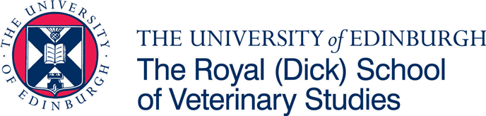
The University of Edinburgh

Royal (Dick) School of Veterinary Studies

Professional Doctorate in Veterinary Medicine (Residency) in Equine Surgery

Applications are invited from veterinary graduates for a Residency in Equine Surgery and Professional Doctorate in Veterinary Medicine (DVetMed). The Residency/scholarship will commence in September 2026 and will run for a four-year fixed-term, renewable annually subject to completion of required DVetMed components.

The position will be based at the Dick Vet Equine Hospital, Easter Bush Campus, Roslin, where the resident will participate in the diagnosis and treatment of surgical and orthopaedic cases, as well as out of hours’ emergencies. Relevant postgraduate clinical experience including at least a one-year rotating internship or at least two years clinical practice in equine/mixed practice is required, and candidates must be eligible to become a member of the RCVS. Applicants should also hold appropriate English language qualifications, where necessary.

The successful applicant will register for the European College of Veterinary Surgeons (ECVS) Diploma in Equine Surgery and a doctorate of veterinary medicine degree with clinical and teaching duties. The residency will be supervised by Mattie McMaster DVM, MS, DACVS-LA, DECVS, MRCVS.

The world-renowned Dick Vet Equine Hospital has a diverse group of staff with recognized specialists in surgery, medicine, dentistry, neurology, anaesthesia, behavioural medicine and imaging supported by a team of nurses and grooms. The Hospital also benefits from visiting farriers and physiotherapists. Recent investment in the clinic has seen the opening of a state-of-the-art equine diagnostic (including MRI and CT), surgical and critical care unit with further imaging development underway.

The residency attracts an annual tax-free stipend of £29,600 and an additional allowance of £1,500 per annum available for approved travel, examination fees and CPD. Postgraduate fees will be paid by the University of Edinburgh at UK level.

Informal enquiries are encouraged and may be made to: Dr Padraig Kelly by email at Padraig.Kelly@ed.ac.uk

Applications should be made via the following online form:

https://www.star.euclid.ed.ac.uk/public/urd/sits.urd/run/siw_ipp_lgn.login?process=siw_ipp_app&code1=PTDVMVETMD1F&code2=0073

Please remember to indicate for which specialty you are making the application. For any application related queries, please contact DVetMed@ed.ac.uk.

Closing date for applications: 31st March 2026

Please note that the online form will close automatically after the above date and no applications can be made beyond this date.

Committed to Equality and Diversity

The University of Edinburgh is a charitable body, registered in Scotland, with registration number SC005336

